Name: Period: Date:

Counterclaim Notes

For this essay you will be choosing _________________________________ against your view point.

- Example#1: Although many people believe that social media helps people by staying connected it actually hurts more than helps because it promotes body issues, induces cyber bullying, and is a major distraction.

What is the thesis/claim:

What is the counterclaim:

- Example #2 : Although many people believe that technology is dangerous it actually isn’t because it provides a means of communication, it helps the overall health of individuals, and it has helped people gain knowledge.

What is the thesis/claim:

What is the counterclaim:

Refute or Concede?

- Refute:

- Concede:

YOU NEED TO BE ____________________________________!

Always use the one that ___________________ works for your argument.

3 MODELS OF ARGUMENT ESSAYS

Model #1:

Model #2:

Model #3:

Circle the one we will be using for this argument essay!

Conclusions and MLA Format Notes

What is a conclusion?
Definition:

Your conclusion must:
1.
2.
3.

1. RESTATE THESIS
- You restate thesis _________________________________________________________________

- Example:
Thesis: Dogs are better than cats because they keep you active, you can teach them tricks, and they are very loyal.

Restated Thesis: Although many people believe cats are better than dogs that is not the case. People with dogs are prone to do more outdoor activities which will help them stay active. You can also teach dogs tricks which is something you can’t do with cats. And finally, dogs are loyal and willing to be by your side no matter what.

- Group Example:
Thesis:

Restated Thesis:

2. SO WHAT?
- It lets the reader _____________________________________________________

- It answers the question _____________________________________________

3. CALL TO ACTION:
- It asks the reader to ______________________________________________________

It can ask them to:
-
-
-
-

Example: “People waste thousands of pounds of food daily” what could you ask the reader to do? What could your call to action be?’

-

-

4. EXAMPLES of CONCLUSIONS

- Underline restated thesis
- Put a box around the “so what”
- Circle the call to action

Example 1: (What’s Missing?)
The best vacation spot in the US is Las Vegas because of the shows and attractions, the nice weather year round, and its affordability. So many people have a hard time deciding where to go on vacation because they aren’t familiar with places that they can go to in the US which are not only fun but also affordable. That is why people should research before making their decision of where to go on vacation, otherwise they will miss the opportunity to discover places like Las Vegas.

Example 2: (Great Example)
Although many people believe that Las Vegas is not the best vacation spot in the US it really is. You see, Las Vegas has many shows and attractions such as Cirque du Soleil, dance clubs, and a dolphin habitat. Not to mention, you can take a trip there anytime of the year since the weather is always pleasant. And finally, it is affordable to travel to Las Vegas without breaking the bank like you would in other places in the US. So many people have a hard time deciding where to go on vacation because they aren’t familiar with places that they can go to in the US which are not only fun but also affordable. That is why people should research before making their decision of where to go on vacation, otherwise they will miss the opportunity to discover places like Las Vegas..

MLA Format Notes

Basics:
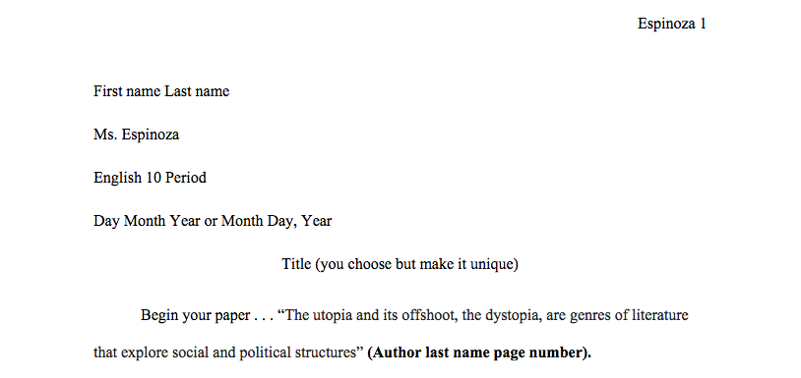

Block Quote:

Titles of Movies and Books:

Work Cited Page:
1. 3.
2. 4.
5.
