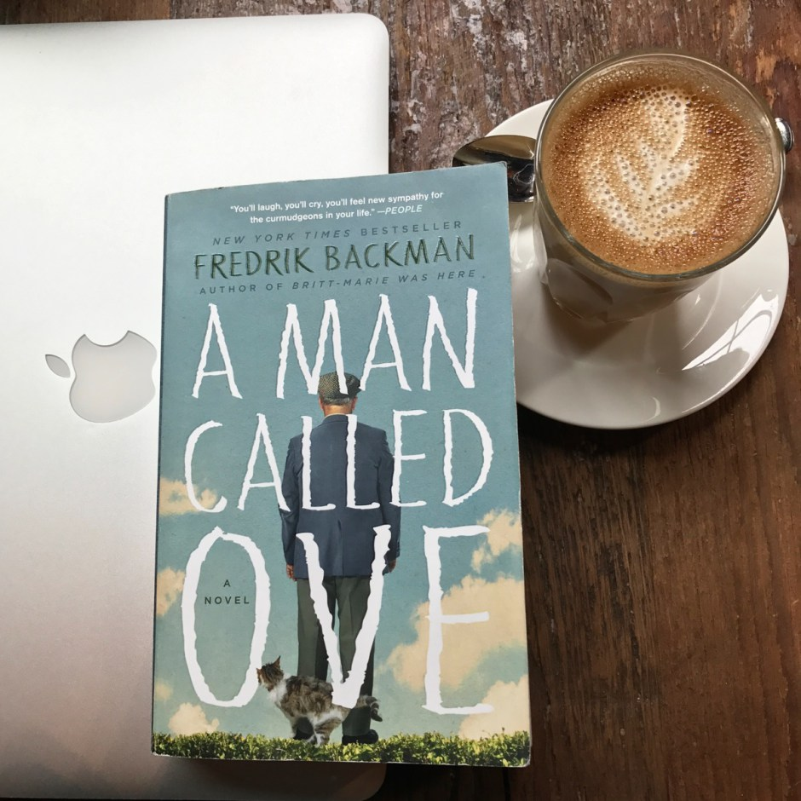
A MAN CALLED OVE
“If you don’t know the story, you don’t know the man” (113).
Unit Questions:
- We are all made up of a multitude of stories - what are your stories and what do they say about you?

- First impressions can be deceiving – how do you know when you really know someone?

Chapter 1-2 (pg. 1-18)
After reading chapters 1 and 2, write two paragraphs in MLA format. Email them to Mrs. Reyes (daisyreyes@alpinedistrict.org).

Paragraph 1: Summarize what happened in the chapters we read today.

Paragraph 2: Give me a detailed description of Ove and share with me what your opinion is of him so far by describing him in one word. Justify the word you chose by using a quote from the reading to back up your reasoning.

A MAN CALLED OVE
“If you don’t know the story, you don’t know the man” (113).
Unit Questions:
- We are all made up of a multitude of stories - what are your stories and what do they say about you?

- First impressions can be deceiving – how do you know when you really know someone?

Chapter 1-2 (pg. 1-18)
After reading chapters 1 and 2, write two paragraphs in MLA format. Email them to Mrs. Reyes (daisyreyes@alpinedistrict.org).

Paragraph 1: Summarize what happened in the chapters we read today.

Paragraph 2: Give me a detailed description of Ove and share with me what your opinion is of him so far by describing him in one word. Justify the word you chose by using a quote from the reading to back up your reasoning.

