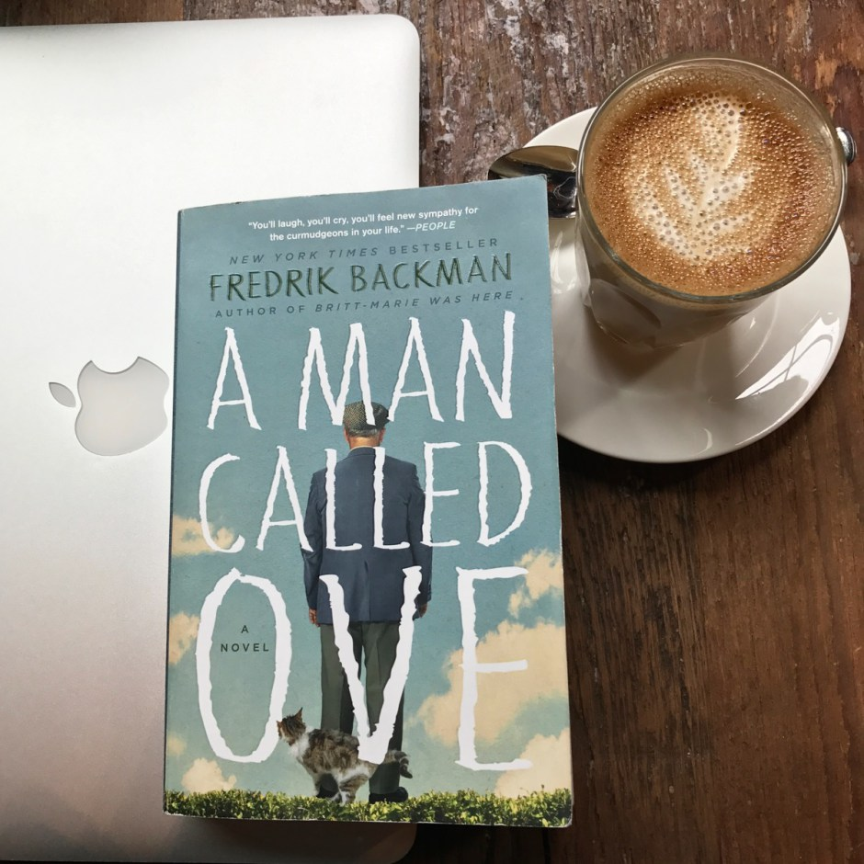
A MAN CALLED OVE – task of the day
“If you don’t know the story, you don’t know the man” (113).
Unit Questions:
- We are all made up of a multitude of stories - what are your stories and what do they say about you?

- First impressions can be deceiving – how do you know when you really know someone?

Chapter 3 (pg. 14-23)
After reading chapter 3 write a paragraph (8-10 sent.) in MLA format answering the following questions.

1. List all of the people Ove meets in Chapter 3 and something about them.

2. How does Ove react to the people he meets – provide a quote to prove your point.

A MAN CALLED OVE - task of the day
“If you don’t know the story, you don’t know the man” (113).
Unit Questions:
- We are all made up of a multitude of stories - what are your stories and what do they say about you?

- First impressions can be deceiving – how do you know when you really know someone?

Chapter 3 (pg. 14-23)
After reading chapter 3 write a paragraph (8-10 sent.) in MLA format answering the following questions.

1. List all of the people Ove meets in Chapter 3 and something about them.

2. How does Ove react to the people he meets – provide a quote to prove your point.

