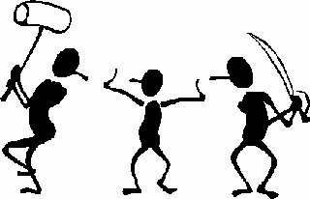
CONFLICTS in “To Build a Fire” by Jack London
Directions: As you read, fill out the table below. Tell me what type of conflict the main character is experiencing, your reasoning, and the quote and page number that backs up your reasoning. Then answer the questions.
Type of Conflict | Reasoning | Quote & Page
1.

2.

3.

4.

5. MAIN CONFLICT is man vs. _______________________________ because

SETTING in “To Build a Fire”

6. Why was setting so crucial to this short story?

7. Below draw and color one of the conflicts that occurred in the story. Make sure to include the setting in your drawing!

