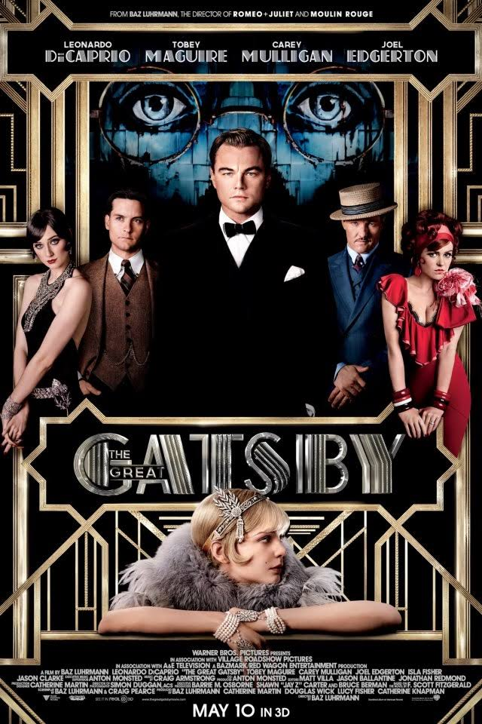
modernism in Gatsby

Before we read The Great Gatsby we need to understand what it was like to live in the 1920’s! Therefore, you and a group of 3-4 will team up to research certain aspects of the 1920’s to learn more about the era in America.
You will write an annotated bibliography for the sources you use on your final product the Google Slide Presentation on the 1920’s Culture in America (1920-1929).
- You will share both your annotated bibliography and your group presentation with daisyreyes@alpinedistrict.org
- Each of you individually will be in charge of only a few slides. However, you are responsible for creating your own annotated bibliography about the slides you are in charge of. (Example: I have to do topics 1-3 (food, clothing, music) so the sources I find will only be on those topics and that is what goes on your personal annotated bibliography). You must have 3 different sources total!
- There has to be pictures and words on each slide
- Topics to be included in your research and slides:
- Food
- Clothing
- Music
- Art
- Slang
- Presidency and major laws
- Gender Roles/Social customs, norms, rules
- Movies/Entertainment
- Inventions/Technology

Annotated Bibliography

You will research your assigned topics for the 1920’s. You should use a minimum of 3 different sources; only two of the three may come from the same genre. You may not use Wikipedia for a source, but feel free to link to sources FROM Wikipedia!
Source Examples:
Books, Magazines/Journals, Newspapers, Television programs, Movies, Internet articles, Personal interviews, Encyclopedias, Songs, Blogs, Hands on Experiences

Annotated Bibliography Info & Example
- What is an annotated bibliography? Why do we need one?
An annotated bibliography is a list of citations to books, articles, documents, media, and other sources. Each citation is followed by a brief (usually about 150 words) descriptive and evaluative paragraph--the annotation. The purpose of the annotation is to inform the reader of the relevance, accuracy, and quality of the sources cited.
It is useful because it helps narrow, evaluate, and organize research.

- What does it look like?
Your annotated bibliography must be in MLA format. It is composed of 4 major parts.
The first part is the citing your source following MLA guidelines. The second is writing a summary about what the source was about. The third is an assessment of the source which is basically identifying the thesis, author’s purpose, and audience. And the last is the reflection of the source which explains how the research will be used in your assignment.
Annotated Bibliography Sample

Example:

Smart 1
Sally Smart
Mrs. Reyes
English 10 A1
05 May 2017
Annotated Bibliography
MLA Citation
Citation: Hague, Graeme. “5 Tips for Learning Guitar Chords.” Uberchord. 29 June 2015. Web.

Summary: This article is written to provide new and prospective guitar
students with some tips and advice on learning to play the guitar.
The article is divided into 5 segments concentrating on 5 tips for
beginners including the following ideas: learn chords slowly and correctly,
try looking away while playing, don’t just avoid harder chords, take time to
learn barre chords, and make sure to know what chords are being played.
What is it about?

Assessment: This article is informative for new guitar students.
The purpose is to provide helpful advice, and the audience is anyone
interested in learning guitar.
What is the thesis, purpose, audience?

Reflection: I will take notes on this article and compare it with other
information I find while researching my topic.
I’ll note the 5 steps and use this information when I create slide 3 in my
How will it help you?
presentation.

*This is an example of what need to do for each source you gather in your annotated bibliography! Each one should look similar to the one above.

