Name: Period: Date:
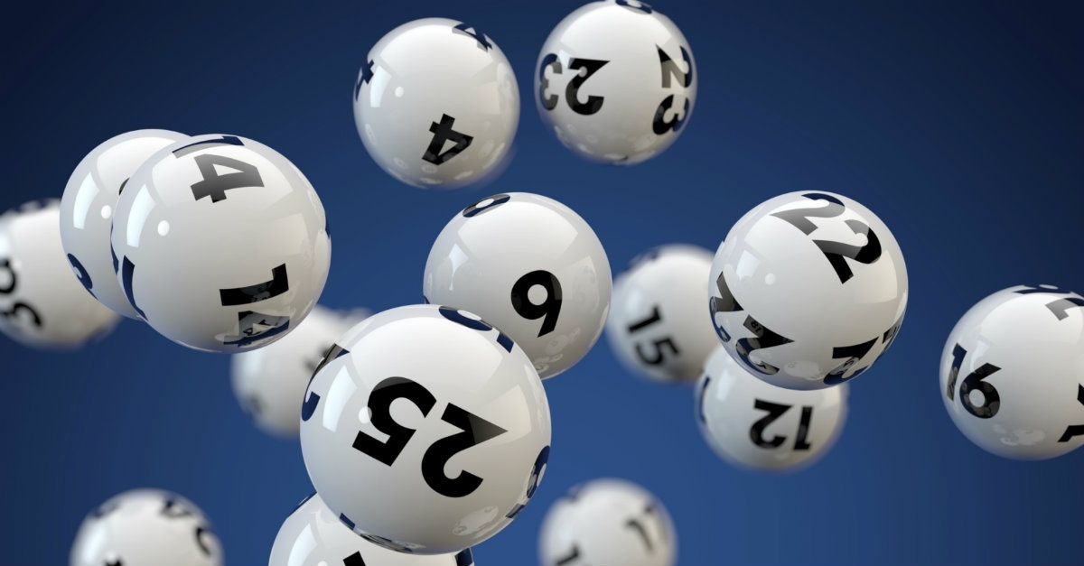
“The Lottery” by Shirley Jackson
Literary Elements vs. Literary Devices

LITERARY ELEMENTS - Below specify where in the short story “The Lottery” the elements are present.

- PLOT (Draw, label, and identify them in the story)

2. CONFLICT (What is the conflict? What type of conflict is it and how do you know?)

3. SETTING (time, place, duration)

4. POINT OF VIEW (What point of view is it in and how do you know?)

5. CHARACTER (Who are the characters, what type of characters are they and how do you know?)
-Protagonist/Antagonist

6. THEME (What is the theme of the story? Explain your reasoning and remember the theme needs to be a complete sentence.)

LITERARY DEVICES – Give me at least 3 examples of any of the devices below that appear in the story and explain your reasoning. Just remember - *there are many more literary devices these are just the ones we will focus on in this specific unit.

1. IMAGERY
2. SYMBOLISM
3. SIMILIE
4. METAPHOR
5. IRONY
6. TONE

